TDS Collections
This project aims to improve the scalability of the THREDDS Data Server through the implementation of a cluster of TDS instances that are deployed in the backend and that are only visible from the outside through a reverse proxy in the frontend. This project also aims to improve the management of the TDS catalogs by partitioning the hierarchy of catalogs into the multiple TDS instances that are deployed in the backend, allowing high availability of the datasets and tackling the current problem of large waiting times after performing a THREDDS reinit when publishing new catalogs.

Keywords
tds gateway, reverse proxy, frontend, backend, THREDDS, TDS, collection, mod_jk, worker, connector, load balancing, instance, replica, urimaps

Entities and relationships
Frontend – Thredds Data Server Gateway and it's components.
Backend – Tomcat servers not visible from the outside and their components. They are accessed bia the frontend.
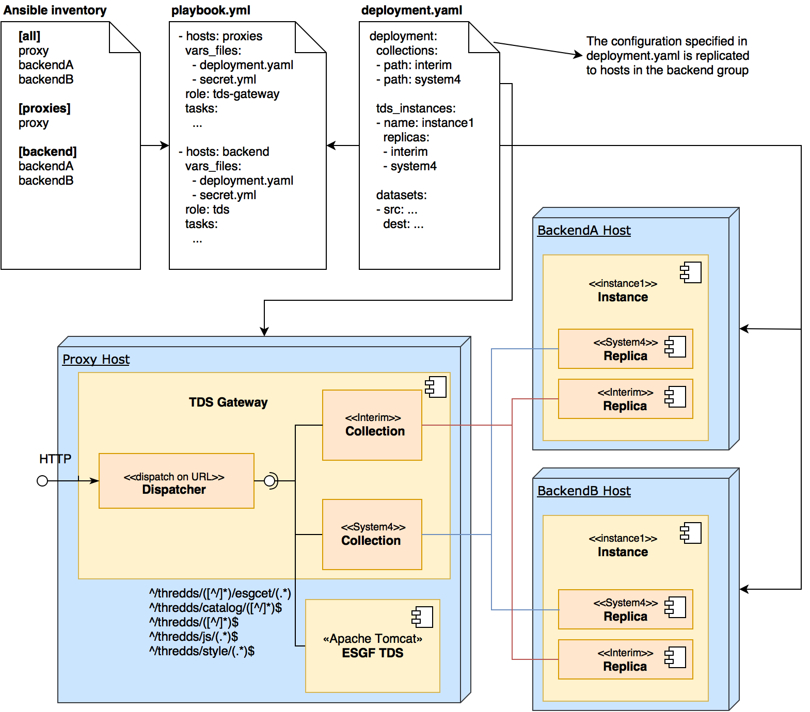

TDS Gateway
The Thredds Data Server Gateway is an Apache web server that works as a reverse proxy, forwarding requests to the backend TDS instances deployed in Tomcat application servers.

Collections
From an user perspective, collections are an aggrupation of catalogs and datasets. For example, the collection Interim would contain all data that belongs to ERA-Interim. Collections have no more meaning to users. However, collections allow system administrators to partition and replicate the catalog and dataset infrastructure into replicas, isolating datasets from the Interim collection from datasets of other collections. Thus, changes to the Interim collection don't have side effects on the datasets of other collections.
From an administrator perspective, collections are mod_jk workers of type load balancing compunded of replicas, that is, mod_jk balance workers. Every replica points to a tomcat instance deployed in the backend hosts. Each request is routed, through the use of urimaps, to the TDS instances that support the collection in which the requested data resides.

Urimaps
Urimaps are rules defined in the configuration of mod_jk that map URLs of requests made by the user to the corresponding collection, in order to be dispatched by one of the instances that belongs to the collection.

TDS Instances
Each TDS instance, or simply instance, corresponds to a Tomcat server proccess running in the backend hosts. Each host can run one or more instances. Each instance can contain one or more connectors (Connector xml elements in Tomcat's server.xml). Connectors of type AJP are used to connect to the TDS Gateway and they are the bridge between the replicas and the instances. Usually, you only need one Connector element per TDS Gateway/reverse proxy in the deployment, since Connector elements must reference their proxy.
Each instance has the option to support any number of collections and each instance will only respond to requests targeting data available in the supported collections. This is done through the TDS Gateway urimaps.

Ansible
Ansible is a tool for automating configuration management and deployment and is uses in TDS Collections in order to automate the creation of the needed infrastructure.
Ansible roles have been created that split the deployment of TDS Collections into reutilizable parts. A user who wants to implement his specific TDS Collections scenario has to define an Ansible inventory and playbook, and also define the variables that the Ansible roles will use to do the deployment.

Overview of roles
The defined Ansible roles are:
- ansible-miniconda-role – Role to install miniconda
- supervisord-conda – Role to install supervisord in a conda virtualenv
- supervisord-virtualenv – Role to install supervisord in a python virtualenv
- httpd – Role to install httpd, either from source code or from system packages
- tds-gateway – Role to deploy the tds-gateway in top of httpd
- tomcat – Role to deploy a tomcat server that will contain multiple instances
- tds – Role to deploy the THREDDS Data Server in tomcat instances

Usage
Useful tags: install, update_catalogs, boot

